

**Department of Computing and Information System**

**Faculty of Science & Information Technology**

**Semester Assignment, Fall 2023**

**Course Code: CIS 222L**

**Course Title: Database Management System and Lab**

**Submitted By: Rayan Ahmed**

**ID:221-16-641**

**LAB PART**

**(a) Develop a database based on normalized tables and show the results through**

**screenshots.**

**Answer:**

Developing a database based on normalized tables and showing the results through screenshots.

Step:-1

At first creating the normalized tables sequentially.

1: Salaries table

2: Departments table

3: Employees

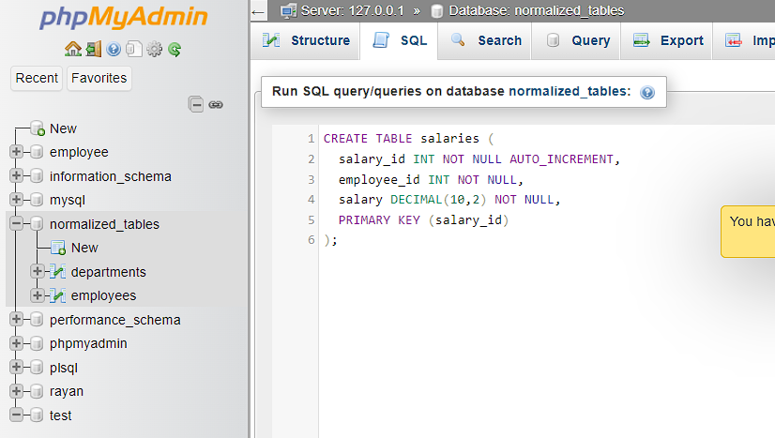

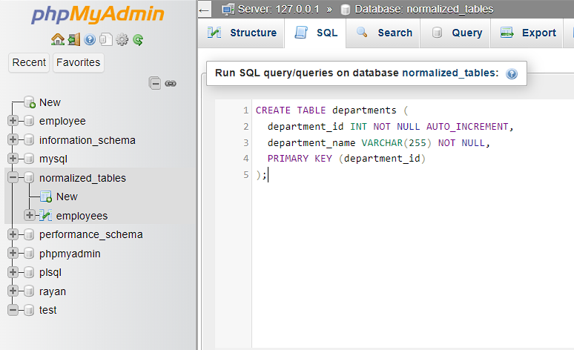

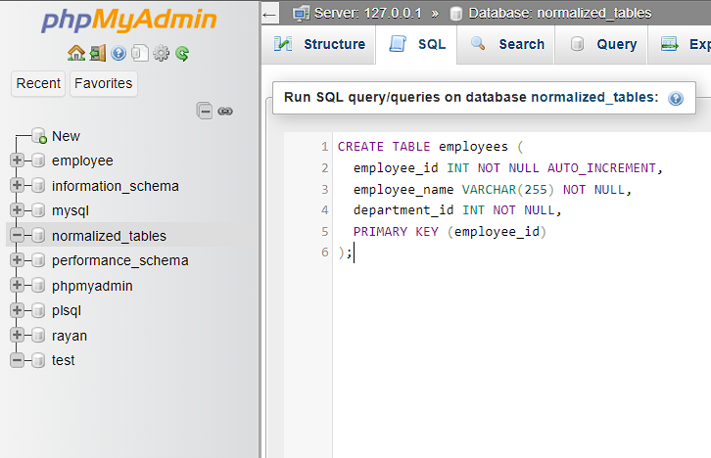

Step:-2

Adding foreign keys with the appropriate refereneces

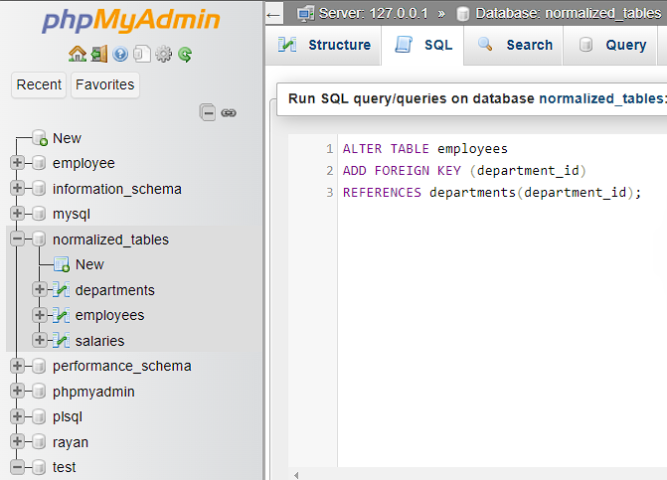

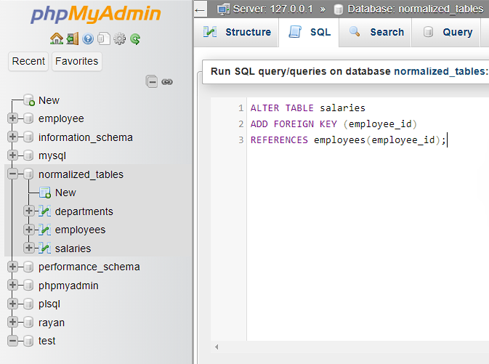

And here we can see that under “Normalized tables” database there are normalized tables.

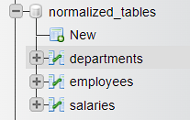

**(b) Insert at least 10 entities in each table.**

**Answer:**

Inserting at least 10 entities in each table

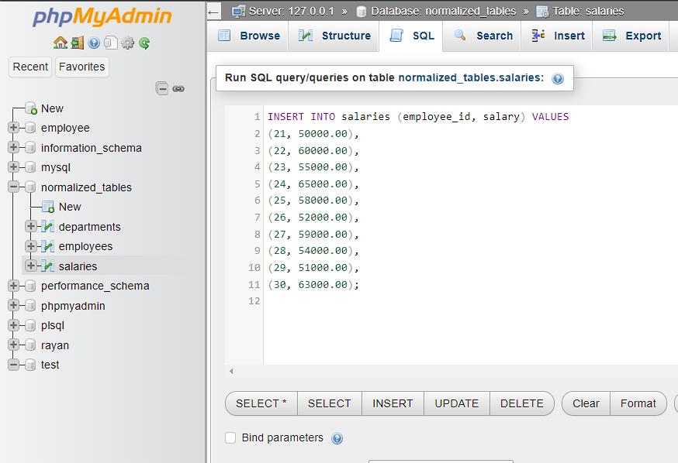

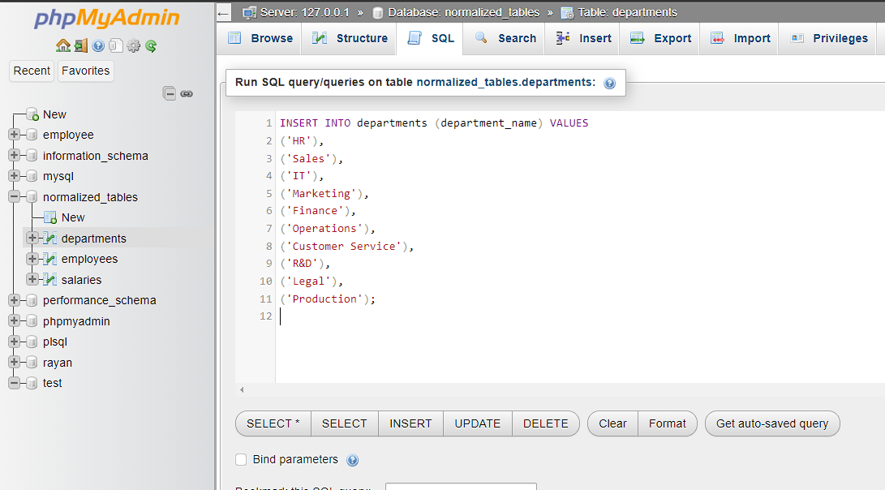

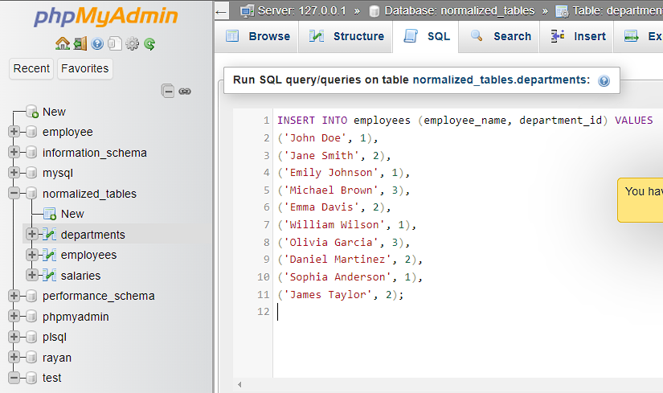

**Out-put with screenshots**

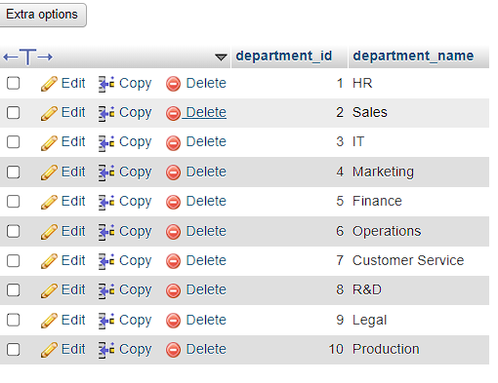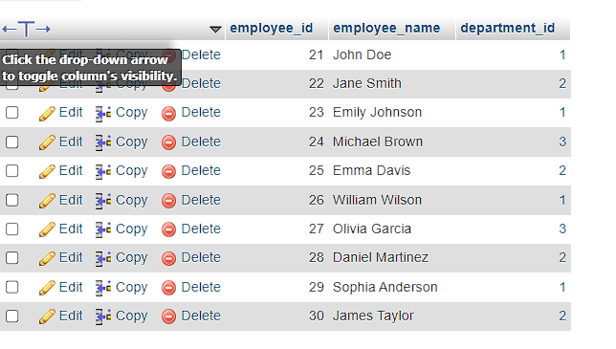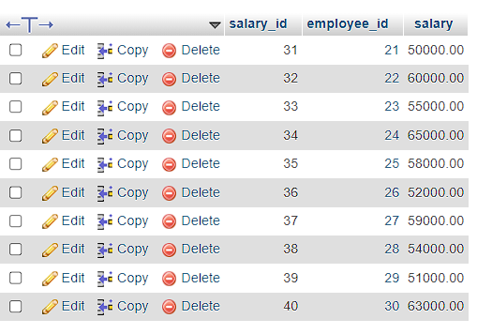

**(c) Write a query to show average salary of employee each department.**

**Answer:**

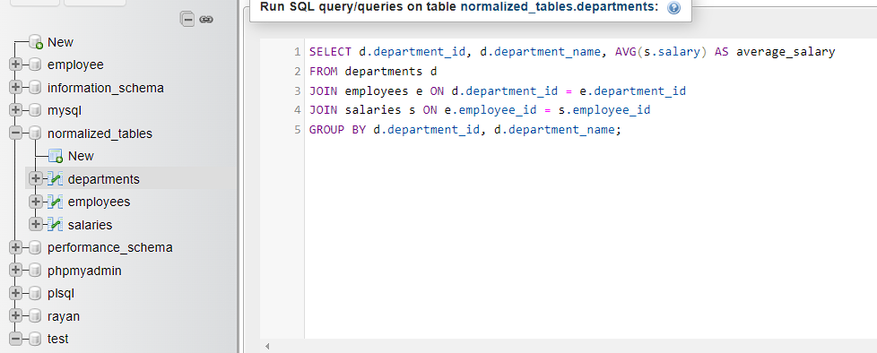

Out-Put:

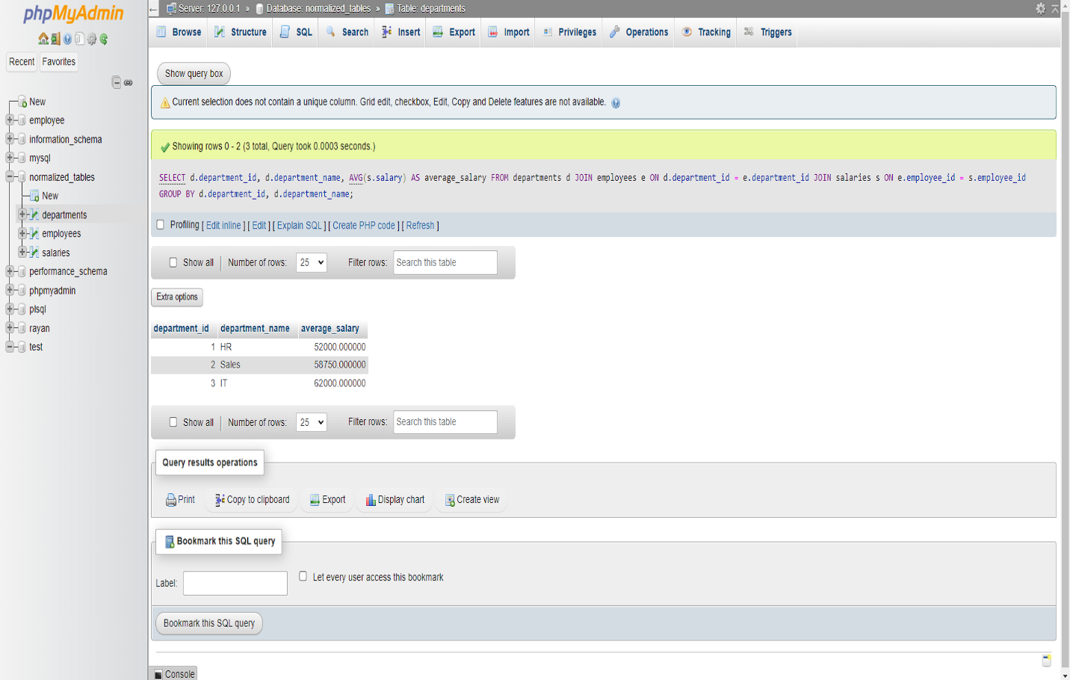

**(d) Write a query to show second maximum salary of employee each department.**

**Answer:**

**Input:**

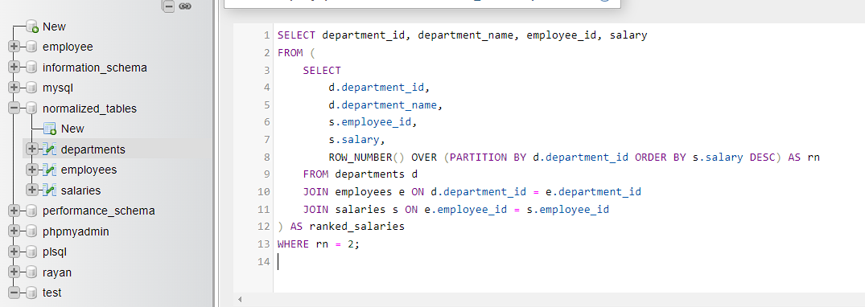

Out-put:

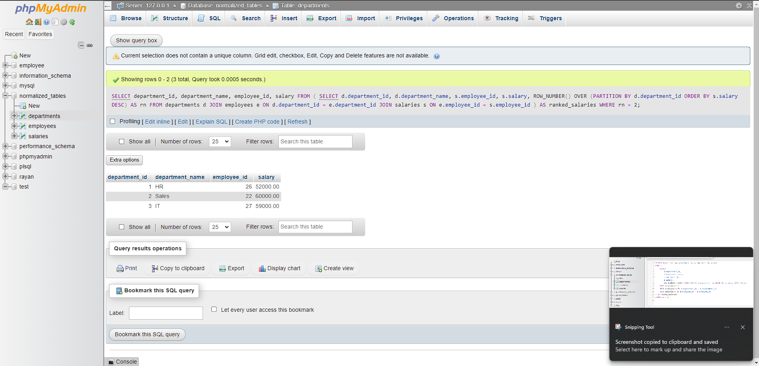

**(e) Write a query to show total number of employee in each department.**

**Answer:**

**Input:**

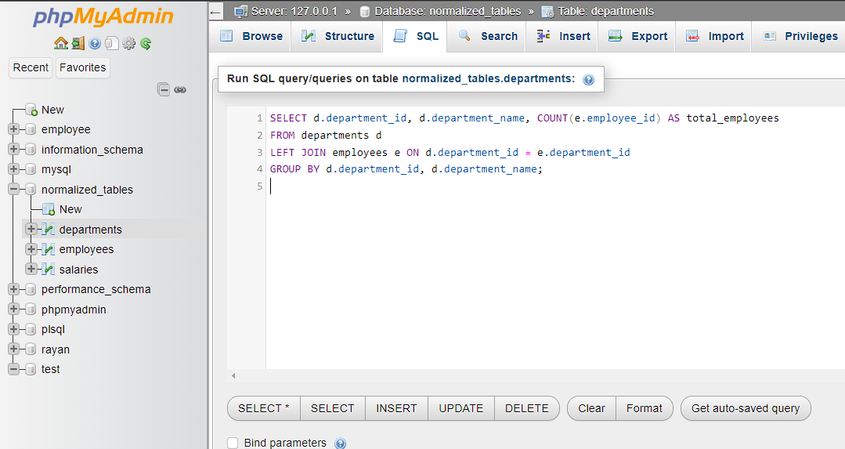

**Output:**

